OS SKILL
SKILL-9
- To Change Directories, Validate Paths, Update Working Directory, Handle Errors, Maintain Previous Directory, Test Navigation.

To Identify Built-ins, Create Dispatch Table, Execute In-Process Commands, Handle Invalid Commands, Maintain State, Test Dispatch Logic.

directory_navigation.c
#define _DEFAULT_SOURCE
#include <stdio.h>
#include <stdlib.h>
#include <string.h>
#include <unistd.h>
#define INPUT_SIZE 256
char previous_dir[INPUT_SIZE] = "";
int has_previous = 0;
/* Change directory and maintain the previous directory */
int change_directory(const char *path)
{
char *current = getcwd(NULL, 0);
if (current == NULL) {
perror("getcwd");
return 1;
}
const char *target = path;
/* cd with no argument changes to HOME */
if (path == NULL || path[0] == '\0') {
target = getenv("HOME");
if (target == NULL) {
fprintf(stderr, "cd: HOME not set\n");
free(current);
return 1;
}
}
/* cd - switches to the previous directory */
if (strcmp(target, "-") == 0) {
if (!has_previous) {
fprintf(stderr, "cd: previous directory not set\n");
free(current);
return 1;
}

target = previous_dir;
}
/* Validate and change directory */
if (chdir(target) != 0) {
perror("cd");
free(current);
return 1;
}
/* Save the directory we came from */
if (strlen(current) < sizeof(previous_dir)) {
strcpy(previous_dir, current);
has_previous = 1;
} else {
has_previous = 0;
}
free(current);
/* Display the new directory */
char *new_dir = getcwd(NULL, 0);
if (new_dir != NULL) {
printf("%s\n", new_dir);
free(new_dir);
} else {
perror("getcwd");
return 1;
}
return 0;
}
int main(void)
{
char input[INPUT_SIZE];
while (1) {
printf("nav-shell> ");
fflush(stdout);
if (fgets(input, sizeof(input), stdin) == NULL) {
break;
}
input[strcspn(input, "\n")] = '\0';
char *command = strtok(input, " \t");
if (command == NULL) {
continue;
}
char *argument = strtok(NULL, " \t");
if (strcmp(command, "cd") == 0) {
change_directory(argument);
} else if (strcmp(command, "pwd") == 0) {
char *cwd = getcwd(NULL, 0);
if (cwd != NULL) {
printf("%s\n", cwd);
free(cwd);
} else {
perror("pwd");
}
} else if (strcmp(command, "help") == 0) {
printf("cd [path] - Change directory\n");
printf("cd - - Return to previous directory\n");
printf("pwd - Print current directory\n");
printf("exit - Exit the program\n");
} else if (strcmp(command, "exit") == 0) {
break;
} else {
printf("Unknown command: %s\n", command);
}
}
printf("Navigation shell terminated.\n");
return 0;
}
OUTPUT
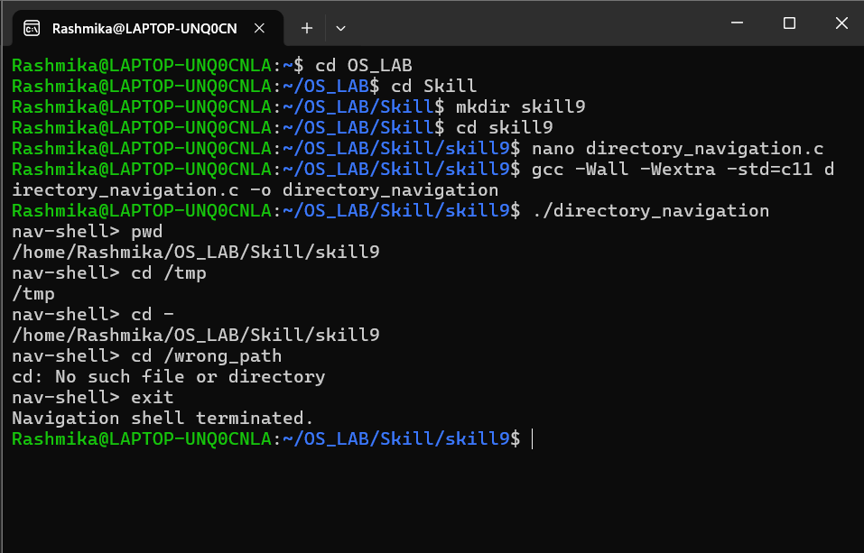
builtin_shell.c

#define _DEFAULT_SOURCE
#include <stdio.h>
#include <stdlib.h>
#include <string.h>
#include <unistd.h>
#define INPUT_SIZE 256
#define MAX_ARGS 10
int running = 1;
int builtin_cd(char **args)
{
const char *path = args[1];
if (path == NULL) {
path = getenv("HOME");
}
if (path == NULL) {
fprintf(stderr, "cd: HOME not set\n");
return 1;
}
if (chdir(path) != 0) {
perror("cd");
return 1;
}
return 0;
}
int builtin_pwd(char **args)
{
(void)args;
char *cwd = getcwd(NULL, 0);
if (cwd == NULL) {
perror("pwd");
return 1;
}
printf("%s\n", cwd);
free(cwd);
return 0;
}
int builtin_help(char **args)
{
(void)args;
printf("\nBuilt-in commands:\n");
printf("cd [directory] - Change directory\n");
printf("pwd - Print working directory\n");
printf("help - Display help\n");
printf("exit - Exit shell\n\n");
return 0;
}
int builtin_exit(char **args)
{
(void)args;
running = 0;
return 0;
}
/* Dispatch table */
struct Command {
const char *name;
int (*function)(char **);
};
static const struct Command commands[] = {
{"cd", builtin_cd},
{"pwd", builtin_pwd},
{"help", builtin_help},
{"exit", builtin_exit}
};
#define COMMAND_COUNT (sizeof(commands) / sizeof(commands[0]))
int execute_builtin(char **args)
{
if (args[0] == NULL) {
return 0;
}
for (size_t i = 0; i < COMMAND_COUNT; i++) {
if (strcmp(args[0], commands[i].name) == 0) {
return commands[i].function(args);
}
}
printf("Unknown built-in command: %s\n", args[0]);
return 1;
}
int main(void)
{
char input[INPUT_SIZE];
while (running) {
char *args[MAX_ARGS];
size_t count = 0;
printf("mini-shell> ");
fflush(stdout);
if (fgets(input, sizeof(input), stdin) == NULL) {
break;
}
input[strcspn(input, "\n")] = '\0';
char *token = strtok(input, " \t");
while (token != NULL && count < MAX_ARGS - 1) {
args[count++] = token;
token = strtok(NULL, " \t");
}
args[count] = NULL;
execute_builtin(args);
}
printf("Shell terminated.\n");
return 0;
}

OUTPUT
